Regulations:
A14

H.T No

Sreenidhi Institute of Science and Technology
(An Autonomous Institution)
Code No:4H214 Date: 04-June-2019 (FN)

B.Tech I-Year II-Semester External Examination, June-2019 (Supplementary)
Mathematics for Biotechnology - II (BT)

Time: 3 Hours Max.Marks:70

Note: a) No additional answer sheets will be provided.
b) All sub-parts of a question must be answered at one place only, otherwise it will not be valued.
c) Missing data can be assumed suitably.

Part - A Max.Marks:20

Answer all QUESTIONS.

1. | Identify the D.E (e^{y} + 1) cos x dx + e^{y} sin x dy = 0 is exact or non exact D.E? | [2M]
2. | Find the particular integral of (D² – 16) y = e^{-4x} | [2M]
3. | Form partial differential equation for z = ax + by + 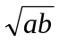 | [2M]
4. | Write Fourier series expansion of f(x) in (c, c + 2) | [2M]
5. | Write conditions to exist Laplace transform of a function? | [2M]
6. | 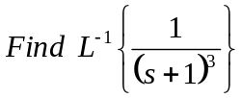 | [2M]
7. | Find integrating factor of 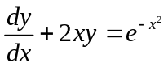 | [2M]
8. | Form partial differential equation for z = (x² + a) (y² + b) | [2M]
9. | Write charge of scale property of Laplace transforms. | [2M]
10. | Solve (D² – 7D + 10) y = 0 | [2M]
Part – B Max.Marks:50
ANSWER ANY FIVE QUESTIONS. EACH QUESTION CARRIES 10 MARKS.
11. | a) | Solve sin 2x 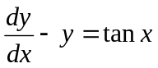 | [5M]
 | b) | A body kept in air with temperature 25⁰ C cools from 140⁰C to 80⁰C in 20 minutes. Find when the body cools down to 35⁰ C. | [5M]
12. |  | Solve (D²+1) y = sin x by the method of variation of parameters. | [10M]
13. | a) | Form a partial differential equation by eliminating arbitrary functions from  z=f₁(x)f₂(y) | [5M]
 | b) | Solve partial differential equation p tan x + q tan y = tan z | [5M]
14. |  | Obtain the Fourier series expansion of f(x) is given that f(x) = 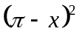in 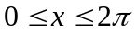 | [10M]
15. | a) | Find the Laplace transform of 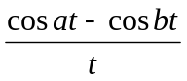 | [5M]
 | b) | Find the Laplace transform of e^{-3t} sin 5t sin3t. | [5M]
16. |  | Solve y¹¹¹ + 2y¹¹ – y¹ – 2y =0 given y(0) = y¹ (0) = 0 and y¹¹(0) = 6 by using Laplace transforms. | [10M]
17. |  | Solve (D³-6D²+11D-6)y = e^{-2x} + e^{-3x} | [10M]
18. | a) | Find 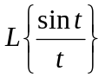 | [5M]
 | b) | Find 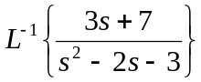 | [5M]
-- 00 -- 00 –

